Program Structures and Algorithms

Spring 2023 (SEC—8)

NAME – Abhinav Ankur

NUID – 002747605

**Task** –

Solve 3-SUM using the Quadrithmic, Quadratic, and (bonus point) QuadraticWithCalipers approaches.

**Evidence –**

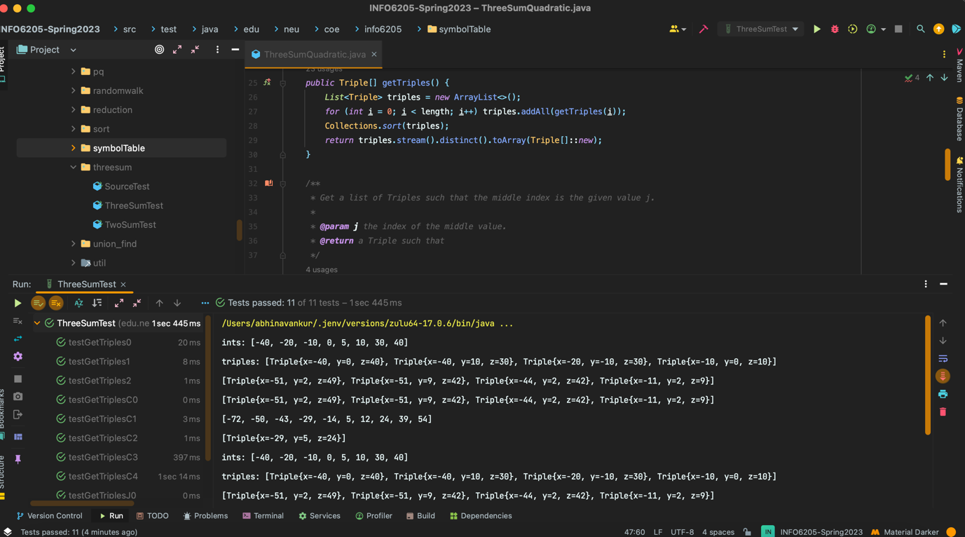

**Spreadsheet –**



**Why quadratic works** –

In terms of time complexity Quadratic and Quadratic with Callipers almost have the same complexity when we see the benchmark in the excel.

Quadratic ~= Quadratic with Callipers < Quadrithmic < Cubic

Quadratic method works so well because instead of getting all the triplets combination and checking them like in cubic, we eliminate the last for loop. First, we use a sorted array. Sorting takes some time but that is comparatively less than the time we save ahead. We loop through each element and consider that the middle element for the triplet. We take two pointers starting from the left and right from that element and increment or decrement the pointers depending on the sum that we get of the triplet. Since we don’t need the third loop, we go from cubic to quadratic.

**Results-**

